Project Edulead

**USER MANUAL**

**Student Lifecycle Management System**

**Module-Academics**

**

**Sustainable Outreach and Universal Leadership Limited**

**Sign off Date Signature Client Signature Consulting**

# 

# About this Manual

This User Manual acts as a reference for ERP- **EduLead** by describing its various concepts and abilities, and by leading the user through the basics of **EduLead** software. It also provides a detailed reference for all of the **EduLead** SLCM (Student Lifecycle Management) functionalities. The User Manual describes all the processes and functionalities regarding various modules and its abilities to conduct the smooth transactions and integrations within the modules.

The software **EduLead** is open-source, easy to use and customize, actively maintained, economical and well supported. Throughout this manual it is assumed that the reader has a working knowledge of about Student Lifecycle Management and basic computer skills and knows how to:

* Use keyboard and mouse
* Use web browsers to access the **EduLead** website
* Locate, open and save data files.
* Edit, cut, paste and text.

The SLCM consists of 3 Modules mainly:

1. Admission
2. Academics
3. Examination

This User Manual consists of the **Academics Module** for End User reference and guidance. The manual describes how to use the Standard interface. As mentioned, it contains instructions that the users must follow during the operation and servicing of **EduLead**. Diverting from the workflow as mentioned in the user manual may result in errors and non-functioning of the software EduLead. It is advisable that the end users must abide by the instructions as mentioned in the user manual.

# Module: Academics

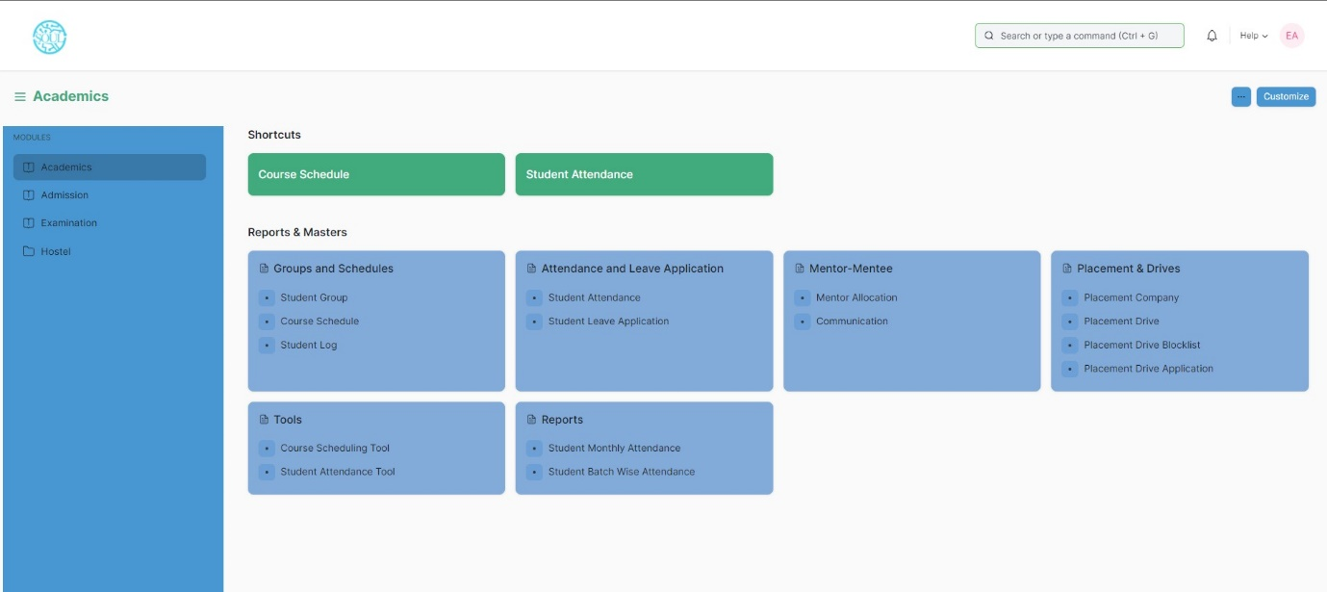

## Groups & Schedules

Groups & Schedules consist of transactions which would allow to form a student group based on various criteria for a particular class and help to schedule classes for different courses for different classes. The transactions in Groups & Schedules consists of:

1. Student Group
2. Course Schedule
3. Student Log

### 1.1 Student Group

The Student Group allows you to create a group of students for different classes for the ongoing Academic Year based on different criterion like:

* 1. Batch
  2. Exam Declaration
  3. Course
  4. Activity
  5. Combined Course
  6. Mentor-Mentee

To access the Student Group Process, go to:

Home > Academics > Group & Schedules > Student Group

#### C:\Users\KIIT\Pictures\Screenshots\Screenshot (83).pngPrerequisites

Before creating a Student Group, it is advisable that you create the following first:

1. Student
2. Class Enrollment
3. Student Batch Name
4. Student Category
5. Instructor

#### How to create a Student Group?

1. Go to the Student Group list and click on ‘Add Student Group’
2. Select and enter the Academic Year
3. Select and choose from the drop-down list for ‘Group Based on’.
4. Batch- Select and enter Class, Section and Batch (from the drop-down).
5. Course- Select and enter Class, Section and Course (from the drop-down).
6. Section- Select and enter Class and Section.
7. Activity- Select and enter Class and Section.
8. Exam Declaration- Select and enter Class, Course and Exam Declaration.
9. Enter the name for the Student Group
10. Select and Enter the classroom from the drop-down list.
11. Select and Enter the maximum strength.
12. Select and Enter the Student Category(ST/General) from the drop-down list.
13. In the ‘Instructor’ table, enter the details like Course and associated Instructors for the particular Class or Section.
14. Save.
15. 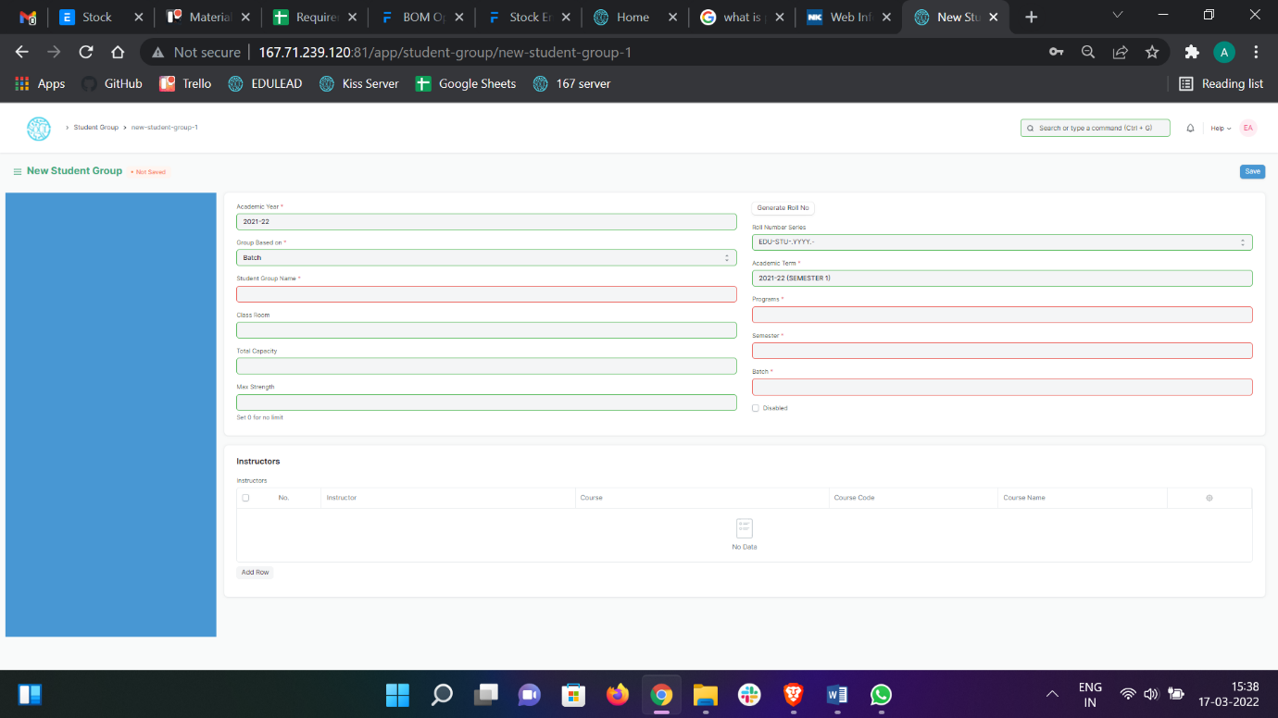Click on the ‘Get Student’ button, all the students present will automatically be fetched on the basis of ‘Group Based On’.

**1.2 Course Schedule**

The Course Schedule can be used for scheduling a particular course by an Instructor or Education Administrator.

Using this feature, a timetable can be created for a University, wherein each slot will be scheduled via Course Schedule.

To access the Course Schedule, go to:

Home > Academics > Group & Schedules > Course Schedule

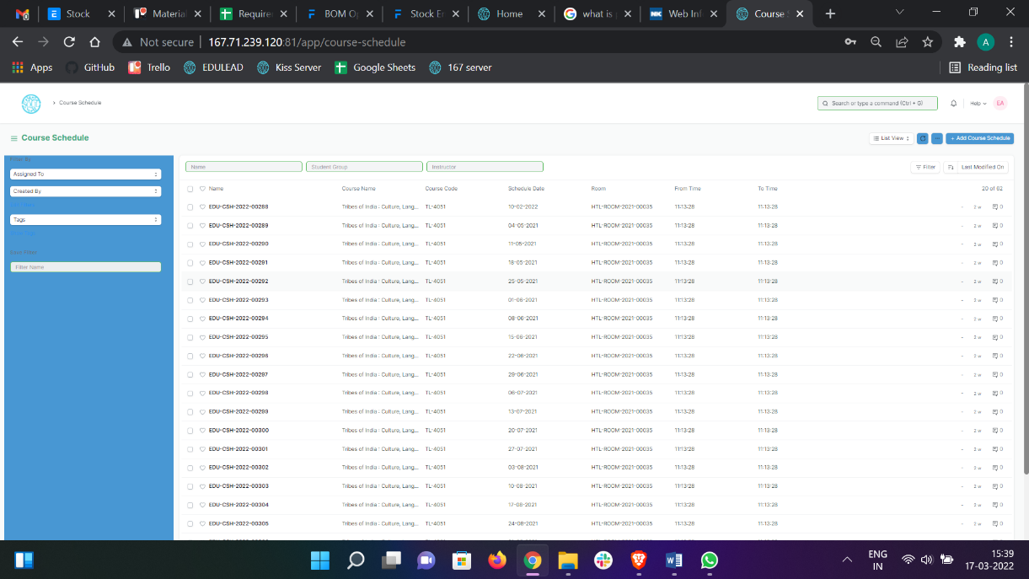

#### Prerequisites

Before creating a Course Schedule, it is advisable that you create the following first:

1. Student Group
2. Instructor
3. Course
4. Class
5. 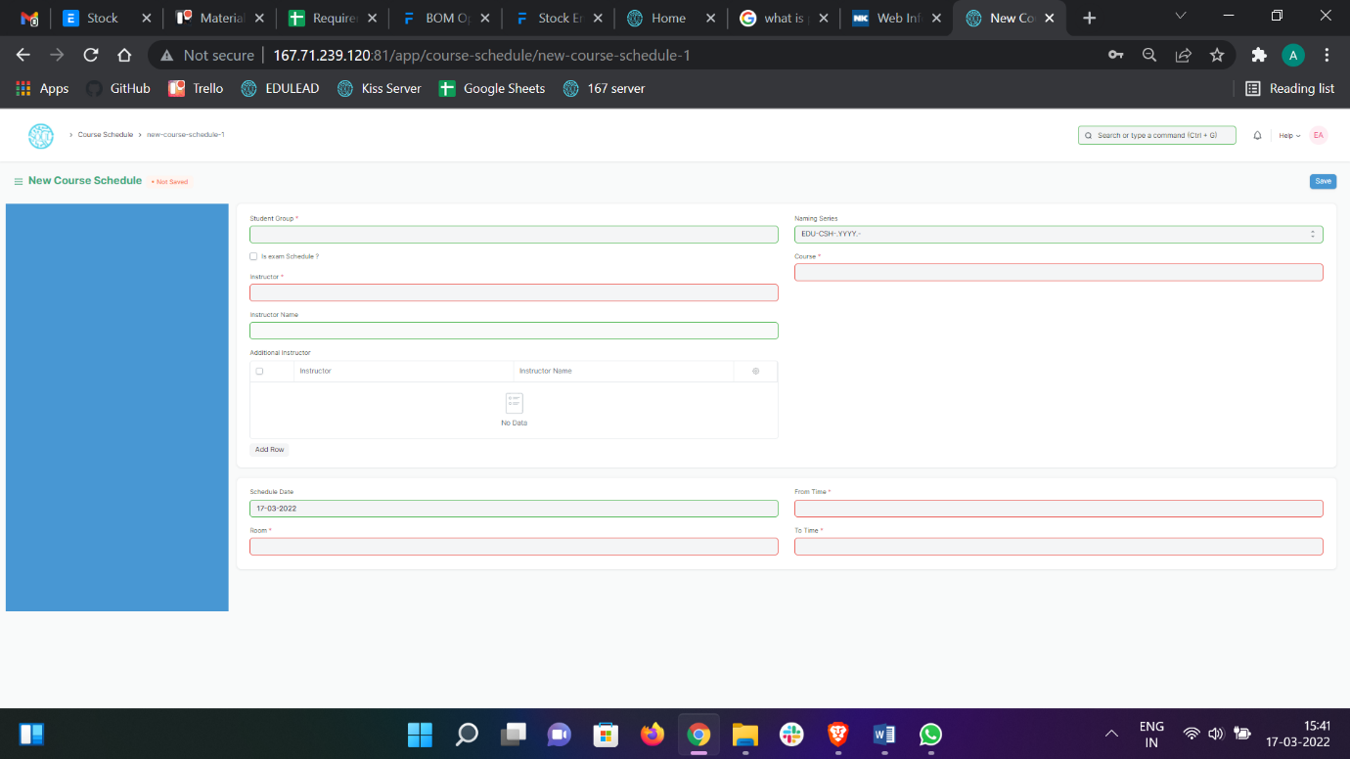Classroom

#### How to create a Course Schedule?

1. Go to the Course Schedule list and click on ‘Add Course Schedule’.
2. Select and enter the Student Group.
3. Select and enter the Instructor who will be tutoring the students for the course.
4. Select and enter the Course from the drop down menu for which the schedule is being prepared.
5. Select and Enter the ‘From Time’ and ‘To Time’ for the course schedule.
6. Select and Enter the Classroom wherein the class could be conducted.
7. Save.

**Note: Course Scheduling Tool can be used for bulk scheduling of a course. **

## Attendance and Leave Application

Attendance and Leave Application consists of transactions which would allow to mark attendance for a particular student of a class and keep the track of leaves for a student. The transactions in Attendance and Leave Application consists of:

1. Student Attendance
2. Student Leave Application

### 2.1 Student Attendance

The Student Attendance allows you to keep track and mark the attendance of a student for a day. Attendance records can be created against Students on a daily basis.

To access the Student Attendance process, go to:

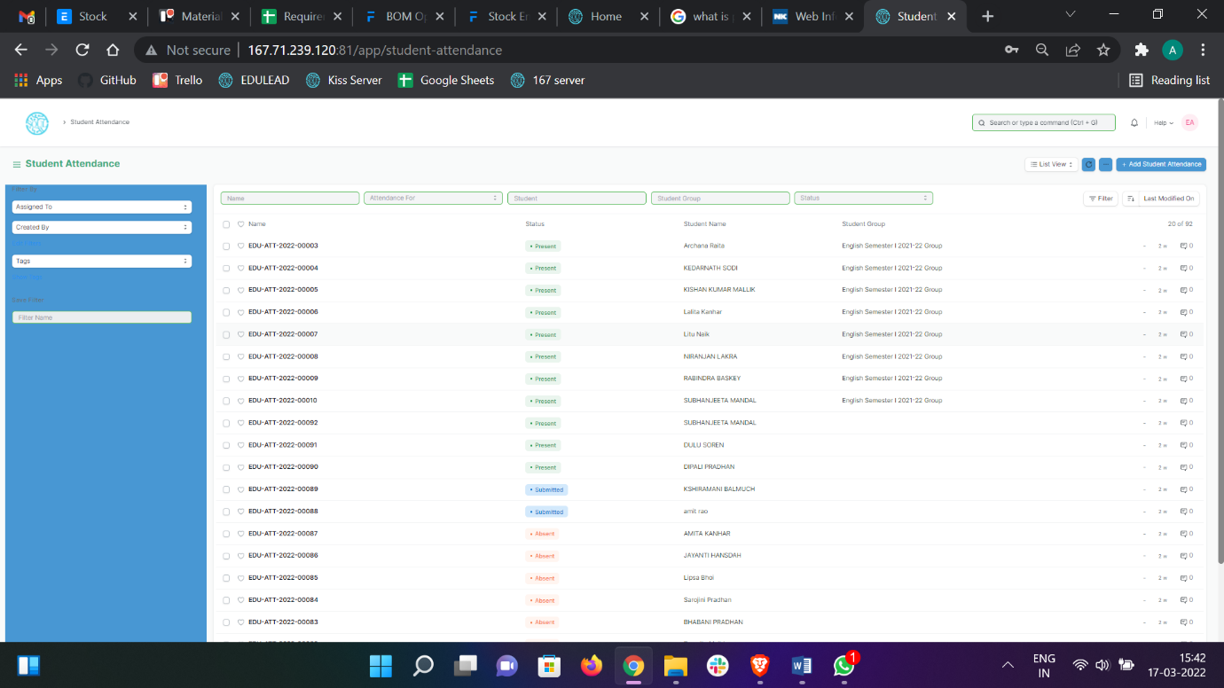Home > Academics > Attendance and Leave Application > Student Attendance

#### Prerequisites

Before creating a Student Attendance, it is advisable that you create the following first:

1. Student
2. Course Schedule
3. 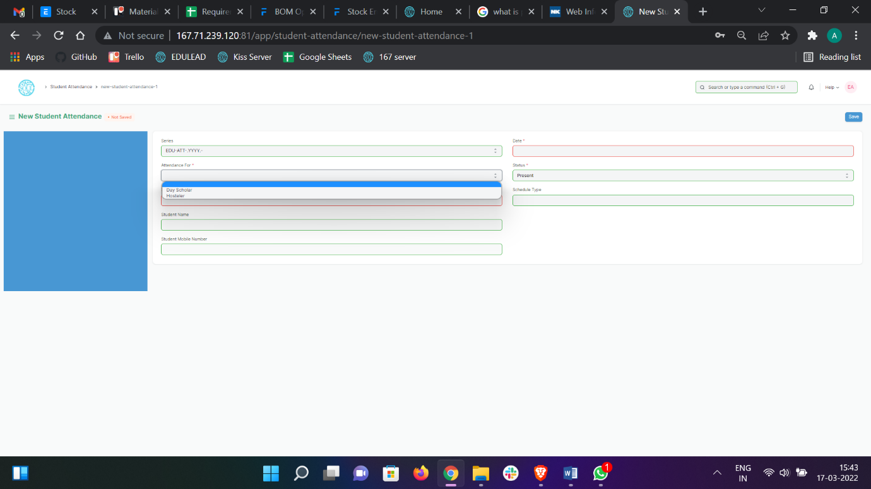Student Group

#### How to create a Student Attendance?

1. Go to the Student Attendance list and click on ‘Add Student Attendance’.
2. Select and enter the Student.
3. Select and enter date and course.
4. Select and enter the Student Group and Course Schedule.
5. Set the Status to Present/Absent/On Leave.
6. Save and Submit.

**Note: The Attendance can be marked for the Exams and also the Student Attendance Tool can be used for bulk updation of the attendance. **

### 2.2 Student Leave Application

The Student Leave Application allows you to keep a track of leaves for a Student.

To access the Student Leave Application process, go to:

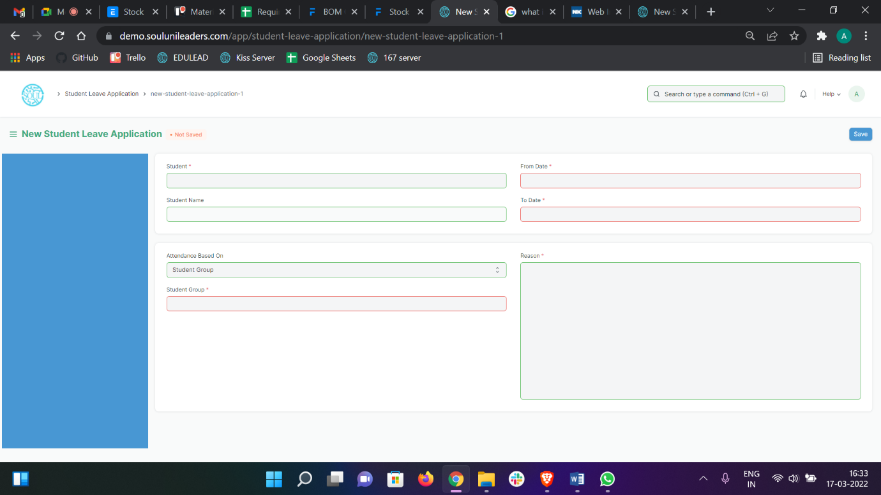Home > Academics > Attendance and Leave Application > Student Attendance

#### Prerequisites

Before creating a Student Leave Application, it is advisable that you create the following first:

1. Student
2. Student Group

#### How to create a Student Leave Application? (From Student Login)

1. Go to the Student Leave Application list and click on ‘Add Student Leave Application’.
2. Student details like Student Name, Student ID, Student Group will be auto-fetched.
3. Select and enter “From Date” and “To Date”.
4. Select and enter Reason.
5. Save.

**Note: The Attendance will be marked automatically**

## Mentor-Mentee

Mentoring is a guidance system where one person (the mentor) imparts their knowledge, skills, and experiences with another person (the mentee or student). The goal of mentorship is to help mentees learn skills and information that will help lead them to success in their careers. Mentors are available to offer and serve as a resource to the mentee whenever a need may arise.

Mentoring is more than just sharing knowledge. Mentors help mentees identify their own goals and offer empowerment and encouragement to guide them to achieve their goals, or solve any challenges along the way. Mentors aren’t intended to dictate how to do something, but rather, they are there to offer insight and support as their mentees develop their own methods during their career path.

* 1. **Mentor Allocation**

Mentor Allocation is a process in which Mentors (Instructors) are allocated to different student groups or students on various basis. It can either be a hostel mentor allocation or program wise allocation.

To access Mentor Allocation, go to:

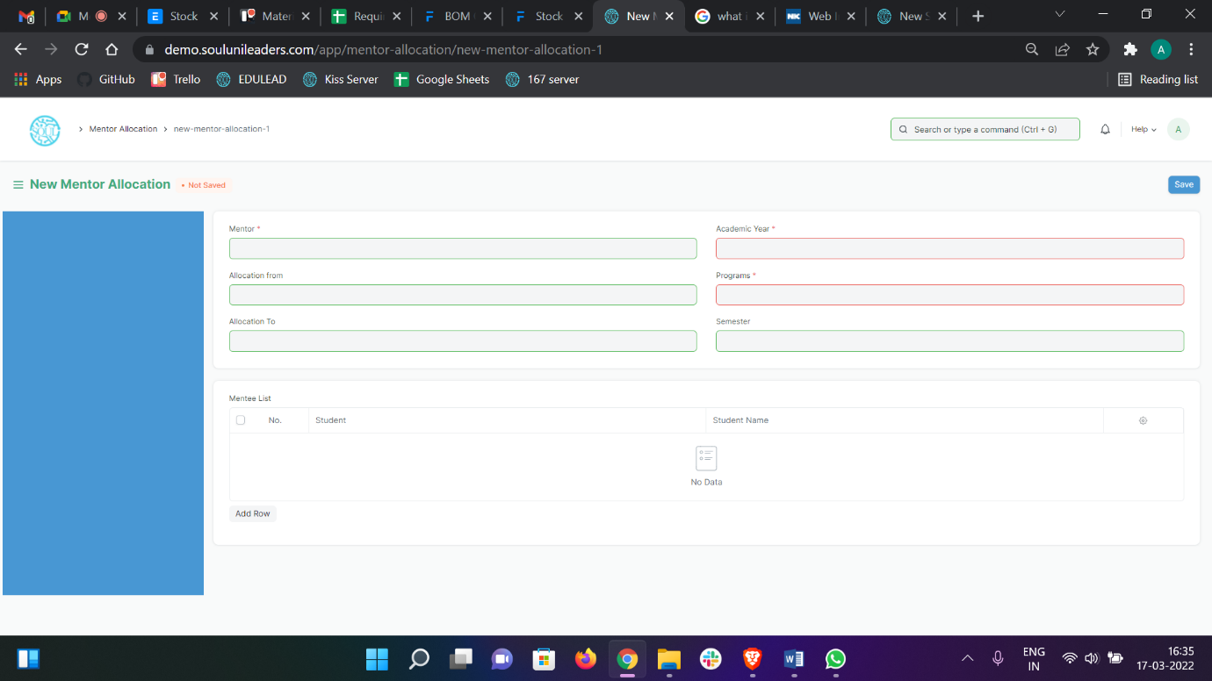Home > Academics > Mentor-Mentee > Mentor Allocation

#### Prerequisite

* + - 1. Student
      2. Program
      3. Semester

#### How to create Mentor Allocation?

1. Click on add Mentor Allocation.
2. Select and add Mentor from the dropdown list.
3. Select and enter Academic Year.
4. Select and enter Program and Semester.
5. Select and enter the period in “Allocation from” and “Allocation to”.
6. Select and enter the student in Mentee List.
7. Save and submit.
   1. **Mentor-Mentee Communication**

As in any relationship where information is being shared on an on-going basis, you and

your mentee need to interact and communicate effectively. Communicating accomplishes three basic things - It is used to get things done, to indicate feelings and thoughts, and to develop the relationship. In impersonal interactions, a minimum of these three things are accomplished. But in a mentoring relationship, the communication process should accomplish all three tasks.

To access Mentor Mentee Communication, go to:

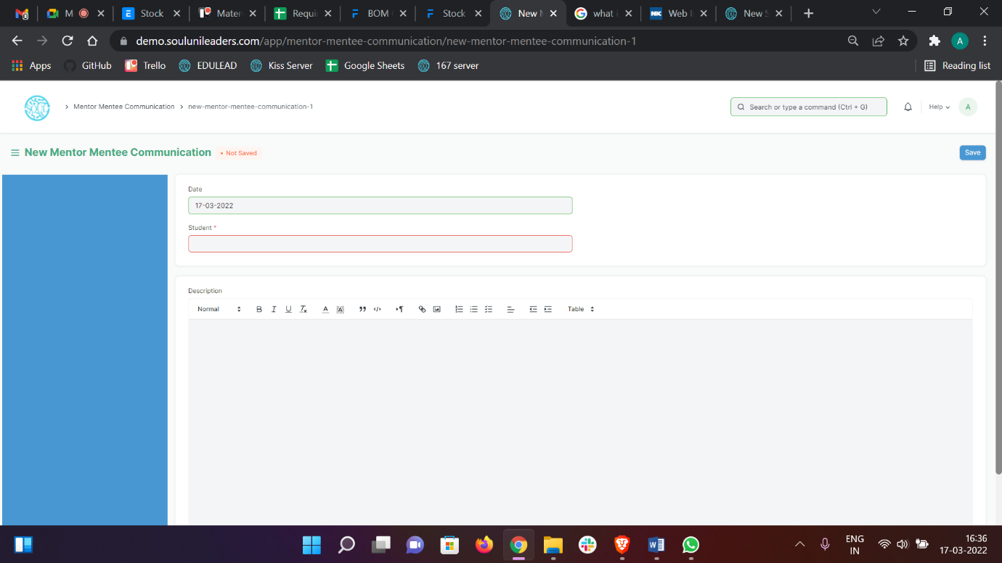Home > Academics > Mentor-Mentee > Communication

#### Prerequisite

* + - 1. Mentor Allocation

#### How to create Mentor-Mentee Communication?

Go to Communication, click on add Mentor Mentee Communication.

* + - 1. Select and enter the Student for whom communication is implemented.
      2. The details regarding the student is auto-fetched.
      3. Enter the details of the Communication in the Description Box.
      4. Save and submit.

## 4. Placement & Drives

Placement refers to the process of connecting the selected person and the employer in order to establish an ongoing employment relationship. It is the determination of the job to which an accepted candidate is to be assigned and his assignment to that job.

1. **Placement Company**

A placement agency is an organization or agency which connects candidates (fresher and experience) to employers (of companies looking for candidates to fill in their vacant positions). A candidate seeking for job can contact a placement consultant or can mail them resume/CV for any available job position matching the candidates profile. These placement consultants then contact back the candidates for any vacant jobs matching their qualifications and skills.

To access Placement Company, go to:

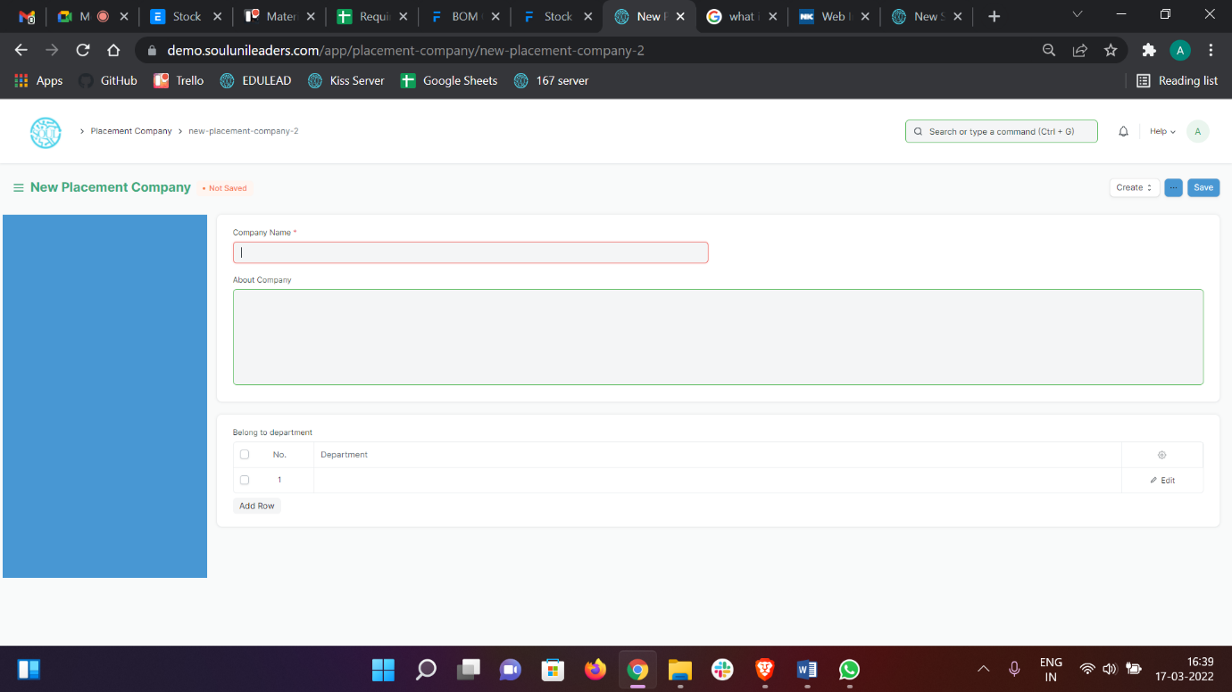Home > Academics > Placement & Drives > Placement Company

#### How to create a Placement Company?

* + - 1. Click on Add Placement Company.
      2. Select and enter Company Name.
      3. Select and enter about Company (if required).
      4. Select and enter Department to which it can belong.
      5. Save.
      6. Select and enter Address of the Company in the “New Address”.
      7. Select and enter Contact details in the “New Contact”.
      8. Save.

1. **Placement Drive**

Placement drives are golden opportunities that every college student eagerly awaits. Colleges announce a particular period, mostly during the final year of graduation, for companies to visit for college hiring. These placement drives are often conducted over a long period including three important phases – pre campus placement, placement drive, and post-campus placement.

On-campus recruitment drive not only boosts the morale of the students but also provide a brand image to the college/institution. During an on-campus recruitment drive, the students have to face aptitude test, group discussions, technical interview and HR interview.

To access Placement Drive, go to:

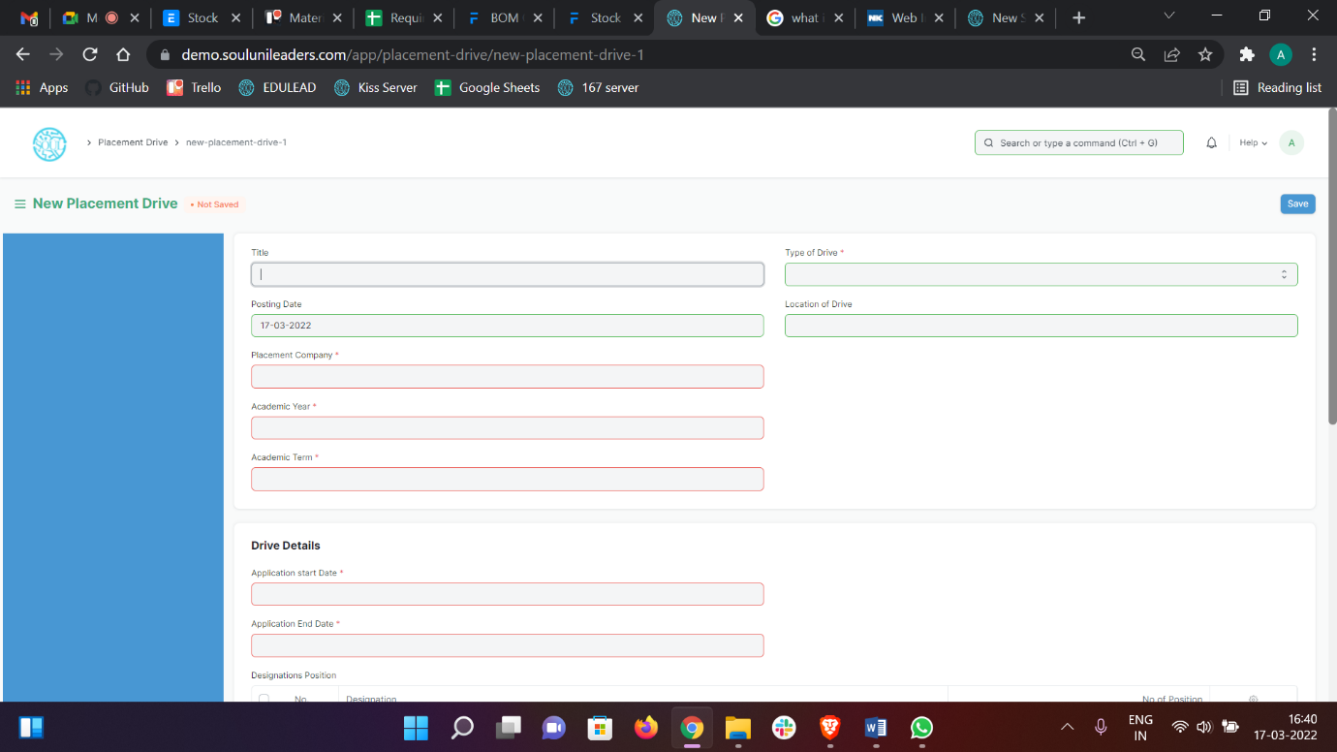Home > Academics > Placement & Drives > Placement Drive

#### How to create Placement Drive?

* + - 1. Go to and click on Add Placement Drive.
      2. Select and enter Title.
      3. Select and enter Type of Drive whether “In-campus” or “Off-Campus”.
      4. Select and enter Placement Company.
      5. Select and enter Application Start Date.
      6. Select and enter Application End Date.
      7. Select and enter Designation and No of Positions.
      8. Select and enter the Programs and respective Semesters for which drive is to be conducted.
      9. Select and enter Eligibility Criteria and Process of Placement.
      10. Save and Submit.

1. **Placement Block List**

It depends whether the internship/placement offer is regular or not If one rejects a regular offer after getting selected, then don’t think the PAT office will trouble you much. In this case, you will be eligible for the rest of the placement drives of other companies.

The placement department has every right to debar a student from selected or further placement drives based on any disciplinary actions or complaints.

To go to Placement Block list, go to:

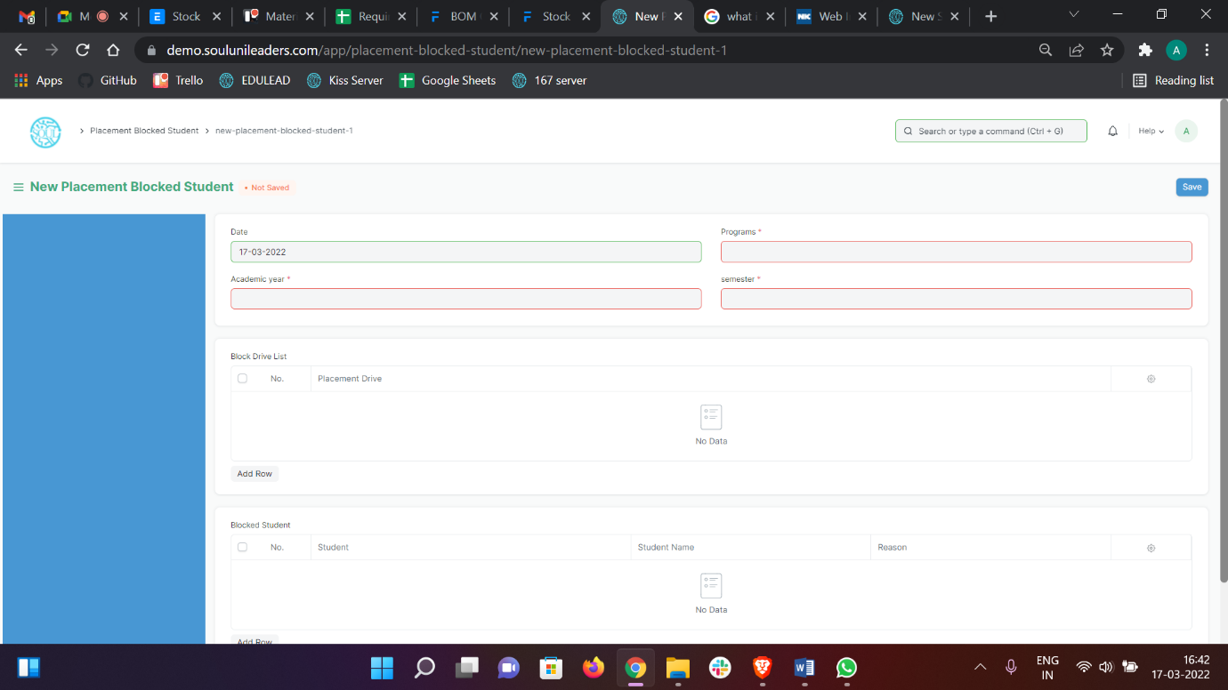Home > Academics > Placement & Drives > Placement Block List

#### How to create Placement Block list?

1. Click on Add Placement Blocked Student
2. Select and enter Program and Semester.
3. Select and enter the Placement Drive from which the students are to be blocked.
4. Select and enter the student name in the Blocked Student table.
5. Save and Submit.
6. **Placement Drive Application**

Placement drives are golden opportunities that every college student eagerly awaits. Colleges announce a particular period, mostly during the final year of graduation, for companies to visit for college hiring. Placement drive application are filled by students who are applying for the respective company.

To go Placement Drive Application, go to:

Home > Academics > Placement & Drives > Placement Drive Application

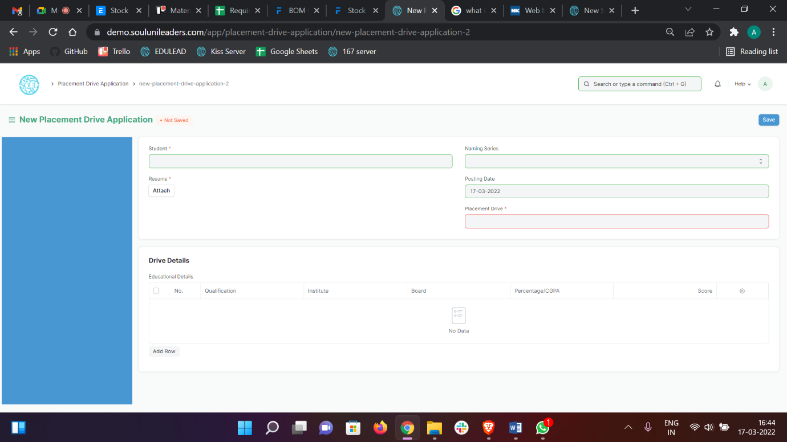

#### Prerequisites

* + - 1. Placement Drive

#### How to create Placement Drive Application?

Go to Placement Drive Application, click on Add Placement Drive Application.

Select and enter Student.

Select and set the value for Naming Series.

The details of the Student are auto fetched accordingly.

Select and enter the Placement Drive.

Select and attach Resume.

Save and Submit.

## Tools

### Course Scheduling Tool

The Course Scheduling Tool allows you to create Course Schedules in bulk for the particular Course.

To access the Student Scheduling Tool process, go to:

Home > Academics > Tools > Course Scheduling Tool

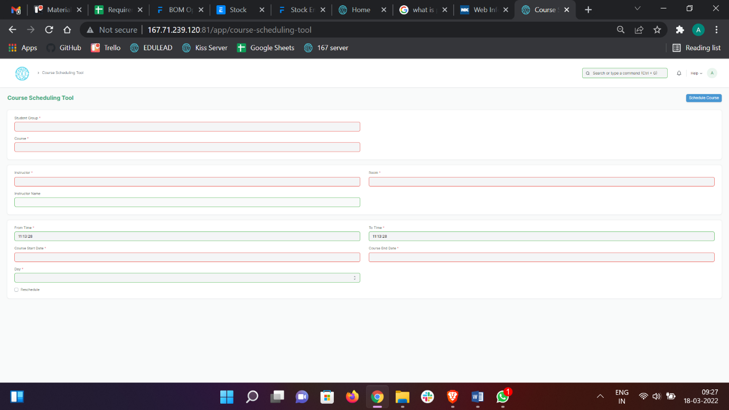

#### Prerequisites

Before using Course Scheduling Tool, it is advisable that you create the following first:

1. Student Group
2. Instructor
3. Course
4. Class
5. Classroom

#### How to use a Course Scheduling Tool?

1. Go to the Course Scheduling Tool.
2. Select and enter the Student Group.
3. Select and enter the Instructor who will be tutoring the students for the course.
4. Select and enter the Course from the drop down menu for which the schedule is being prepared.
5. Select and Enter the ‘From Time’ and ‘To Time ‘for the course schedule.
6. Select and Enter the Start Date and End Date of the Course.
7. Select and Enter the Day.
8. Click on ‘Schedule Course’ Button.

**Note: The system will create the course schedules if the classroom and Instructor are available and there is no conflict for the selected Student Group with other course schedules. **

#### Rescheduling:

1. You can reschedule the course schedules created.
2. Check the ‘Reschedule Checkbox and then click on ‘Schedule Course’.
3. System will delete the existing Course Schedules for the particular Course within the mentioned Start Date and End Date and will create a new Course Schedules.

**The entries for all the Course Scheduling Tools are created in the Course Schedule Document. **

### Student Attendance Tool

The Student Attendance Tool allows you to bulk update the Attendance for Students based on Student Group and Course Schedule.

To access the Student Attendance Tool process, go to

Home > Academics > Tools > Student Attendance Tool

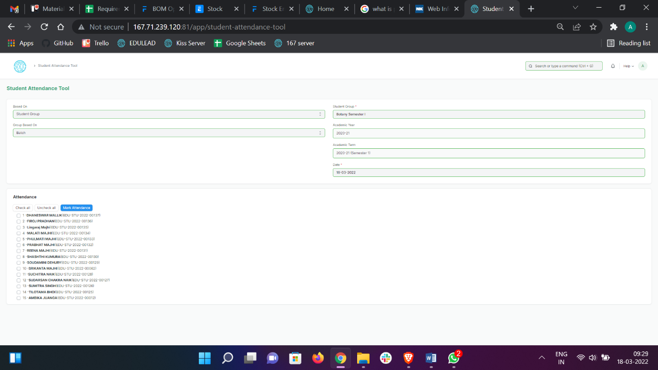

#### Prerequisites

Before using Student Attendance Tool, it is advisable that you create the following first:

1. Student
2. Course Schedule
3. Student Group

#### How to use a Student Attendance Tool?

1. Go to the Student Attendance Tool.
2. Select and Enter the ‘Based On’ from the drop-down menu
3. Student Group: Select and Enter ‘Group Based On(Batch/Section/Activity/Course), Student Group, Academic Year and Date.
4. Course Schedule: Select and Enter Academic Year and Course Schedule.
5. Students will be automatically fetched.
6. Mark the Attendance.
7. Save.

The entries for all the Students’ Attendance Tool is created in the Student Attendance Document.